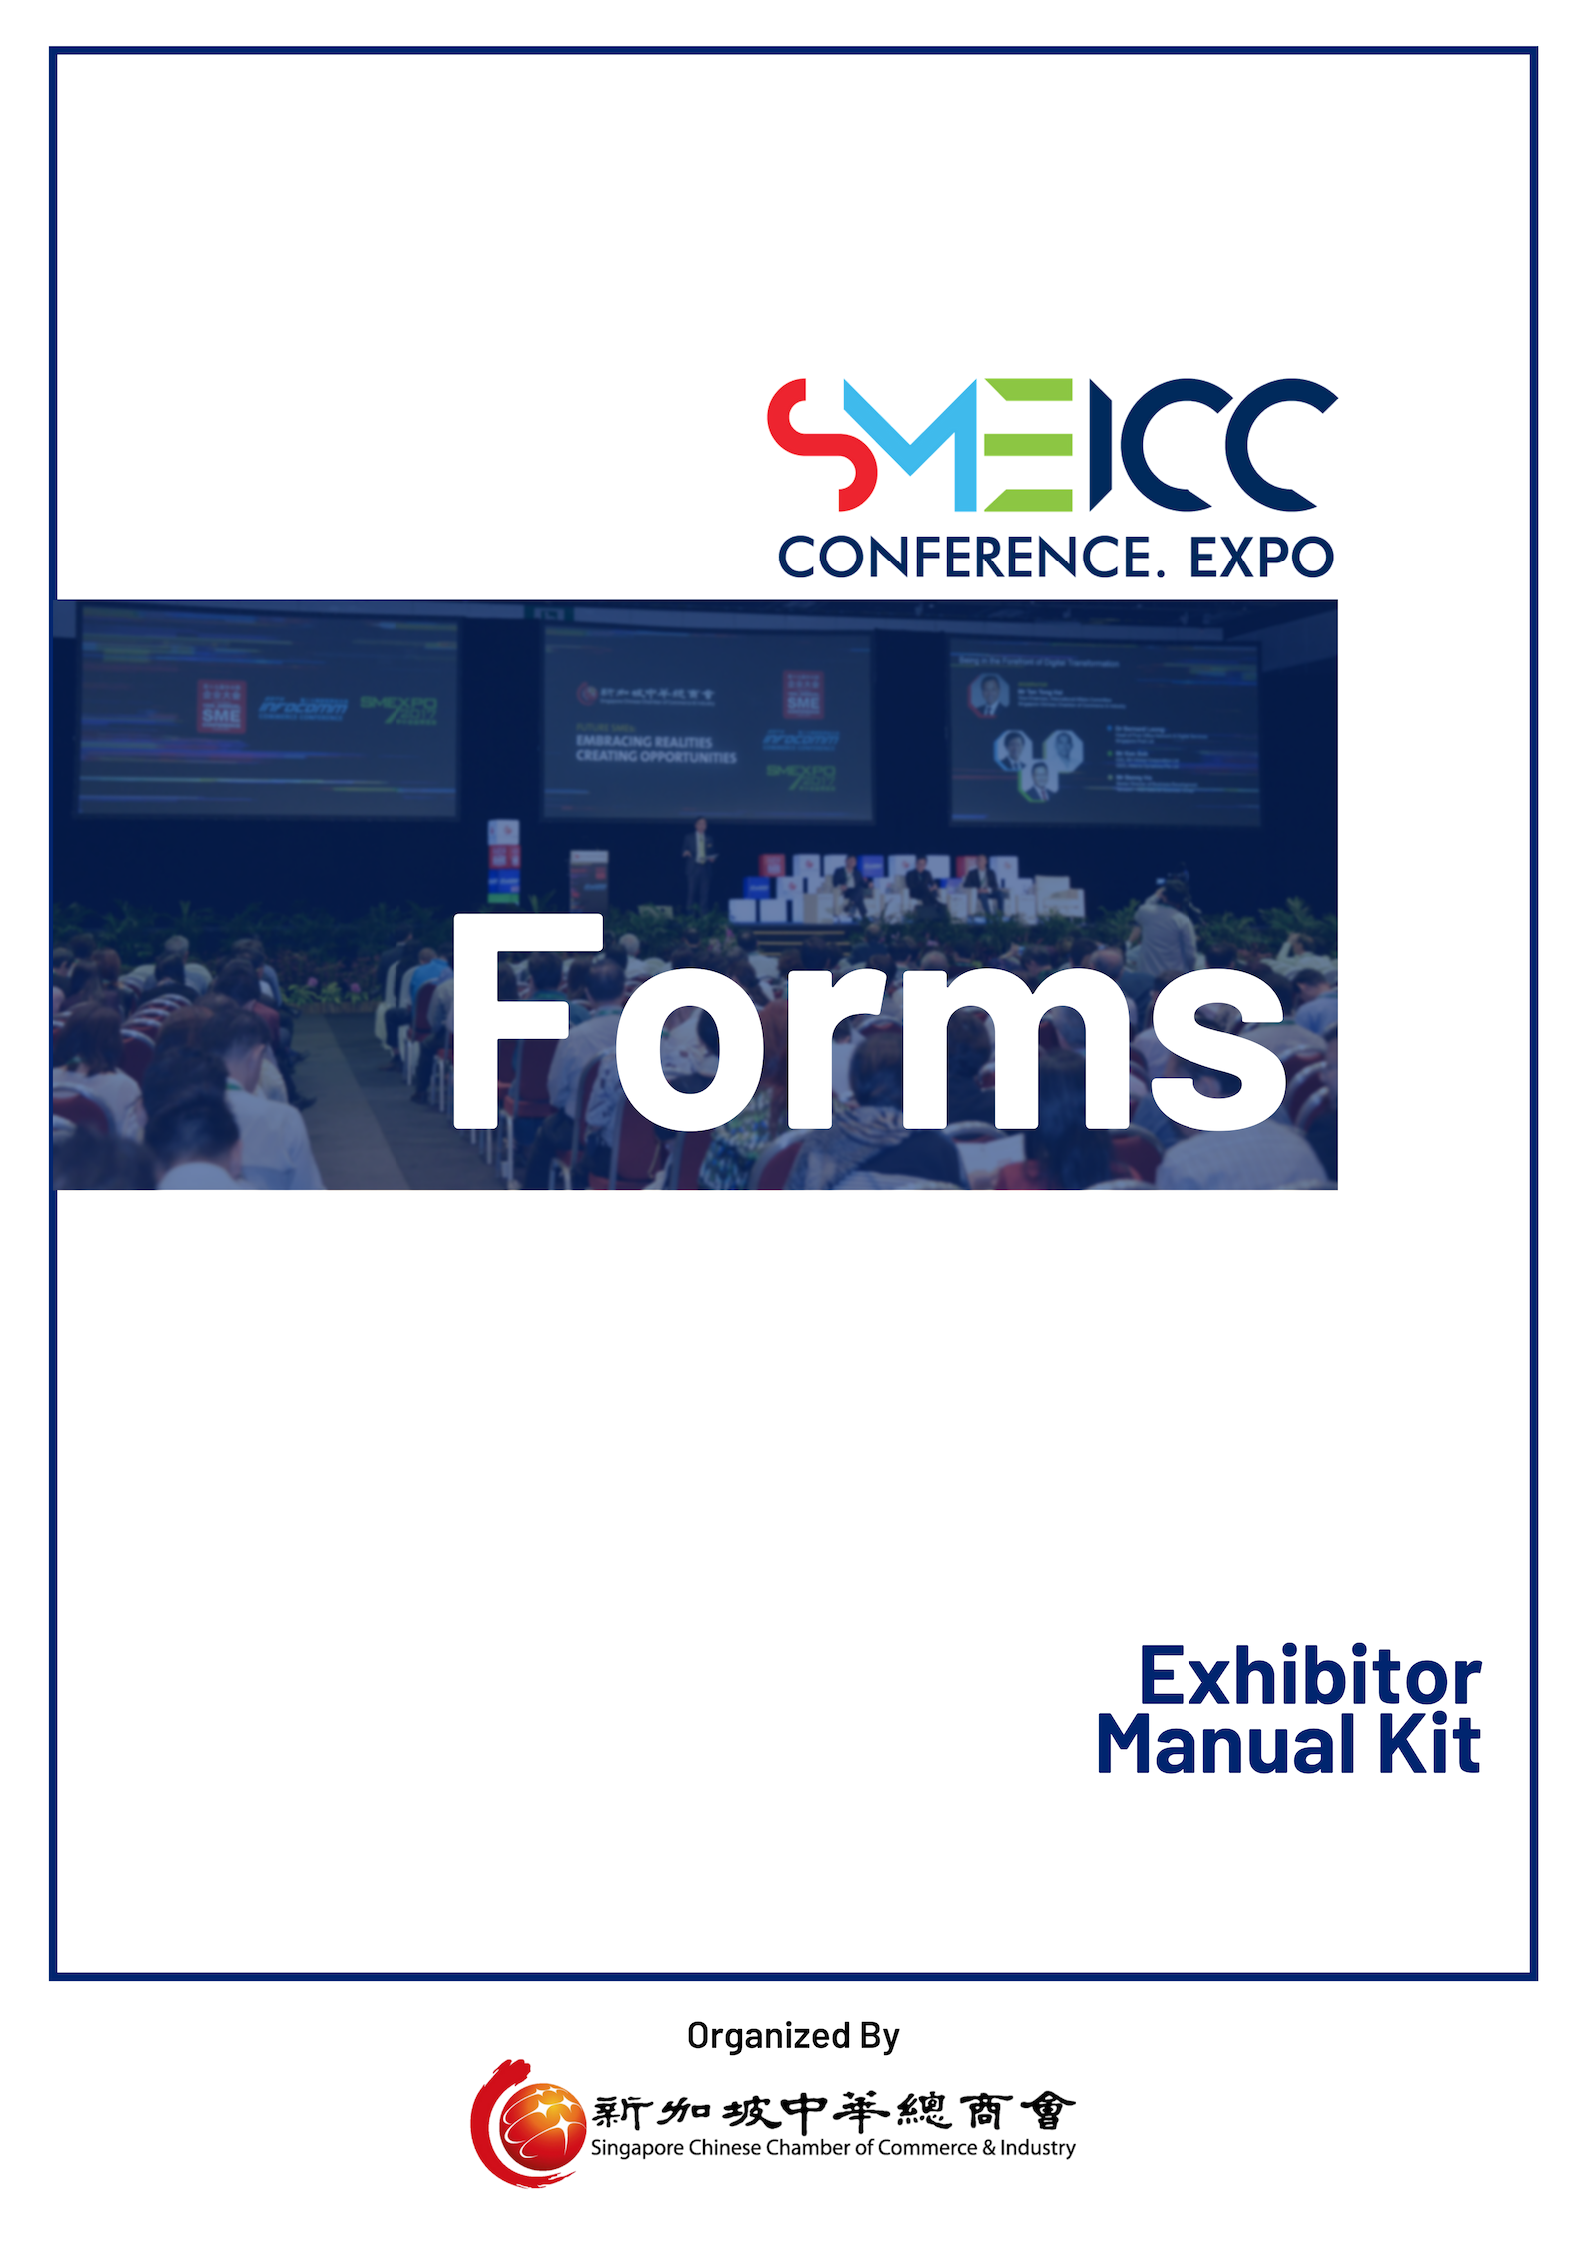
This information will be published under each Exhibitors’ information on the SME ICC website (www.smeicc.org).
Form T1: Solutions Offering and Company Write-Up for Website Listing
Please email this form to:-
SCCCI
Attn: Ms Tiffany Shia | Mr Chris Foo
Email: tiffany@sccci.org.sg | chris@sccci.org.sg
Tel: +65 6430 8312 | +65 6430 8371
FORM T1 - COMPULSORY
For Exhibitors
Form Due: 7 June 2019
Solutions Offering (up to 10 Products/Solutions Listing):-
e.g. ERP Software; CRM System; Cloud Solutions; Technical Support
*Please insert a semi-colon “;” in between each product and/or solution.
Sample of Website Listing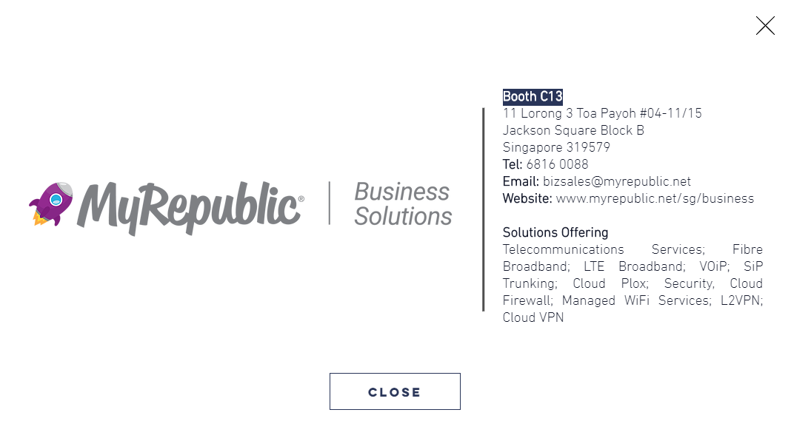
SAMPLE
Solutions Offering

Rules & Regulations
DOs and DON’Ts for Exhibitors
Technical Services Manual

**Special Note to all Exhibitors**
Please abide to the various deadlines.
Late Orders received after 28 June 2019 will be subjected to a 30% Late Surcharge.
A 50% Late Surcharge will be imposed for orders received after 12 July 2019 if the order is still available. Full cost of order shall apply for cancellation received after 12 July 2019.
All items entitled in the package are not interchangeable. Exhibitors may opt for all or part of the items listed. Pictures shown are only artist’s impressions. Exact number of sidewalls and furniture will depend on each individual location and/or exhibitors’ own indicated preferences.
Damage to Stand Structures and Exhibition Premises
- No nailing or use of glue onto the System Panel is allowed. ONLY removable tape is allowed.
- For hanging of heavy material, please contact the appointed contractor for arrangement. Should there be any damaged, the exhibitor will be liable for all the cost involve in reinstalling the damages.

Company Name reflected on the Fascia Board will be according to the name provided in the SME Expo Participation Form under the “Particulars of Participating Sponsor/Exhibitor for Marketing Purpose” portion.
Standard Shell Scheme Fascia & Information
Important Information to Take Note.
For Reading
For Standard Booth Exhibitors
Reading Purpose Only
Should there be a need to change the name on the Fascia Board, please contact SCCCI by 28 June 2019.
Standard Shell Scheme Booth
- Fascia boards are available in Standard Colours only.
- For additional requests, please refer to order forms for Furniture, Electrical, AV & Plumbing. Alternatively, you may contact the appointed official contractor (Cityneon Events) for further assistance for booth set-up.
- Please take note that screwing, drilling, painting or nailing on any of the aluminium frames and existing panels of the standard shell schemes is NOT allowed.
- For Company Logo placement on the Fascia Board, logo previously submitted to SCCCI will be used for the printing. Should there be a need to revise the logo, please contact SCCCI.
Entitlement for Standard Shell package:
Stand Area in m² | 9sqm | 18sqm | 27sqm
Fascia Board Background | Green | Green | Green
Fascia Board Lettering | White | White | White
Booth Carpet | Blue | Blue | Blue
40W Fluorescent Light | 2 | 3 | 4
13amp Power Socket (NOT used for lighting purpose) | 1 | 2 | 3
Lockable Reception Counter [603] | 1 | 2 | 3
Armchair [2103] | 2 | 4 | 6
Wastepaper Basket [707] | 1 | 2 | 3
*For 1-sided opening Standard Booth and non-3m x 3m Standard Booths, actual booths will differ from the above diagram.
- Exhibits should not exceed the height of 2.5metre.
Form T2: Submission of Performance Bond
Please email this form to:-
Cityneon Events Pte Ltd
Cityneon Building, 25 Tai Seng Avenue #06-01, Singapore 534104
Attn: Ms Jade Yang
Email: runqiu.yang@cityneongroup.com
Tel: +65 6571 6271
FORM T2 - COMPULSORY
For All
Form Due: 28 June 2019
- No fixtures are to be made to the walls. Brackets are suggested for the hanging of signs. Velcro or double-sided tape may be used for light items only.
- No fixtures or nails are permitted to any part of the Exhibition Centre and Exhibitors must ensure that arrangements are made in their own designs for all parts of their work to be self-supporting and secure.
- Corner booths will be opened on 2 sides unless otherwise specified by the Exhibitor and approved by the Organiser.
Please take note that a proper flooring protection such as carpet, timber underlay or raised platform is requested for all custom booths before they could construct the booth. Please contact official contractor Jade (runqiu.yang@cityneongroup.com) from Cityneon if you need a quote for custom flooring.

REFUNDABLE PERFORMANCE BOND
Before a contractor/exhibitor is permitted to start work, it is required to place a refundable Performance Bond of S$100.00 per square metres for Raw Space Booth (subject to a minimum of S$1000.00 and maximum of S$5,000.00) and S$200.00 for Shell Scheme Booth with the Event Manager and sign an undertaking to guarantee to conduct proper schedule of production and observance of the exhibition hall regulations. The Performance Bond is to be placed in cash (for Singapore & overseas companies) or cheque (for Singapore companies only). The contractor will only be allowed to bring in exhibits and commence work when this Performance Bond is placed with the Event Manager.
Provided that the booth is completed on time and no damage is caused during the build-up, show days and tear-down, the Performance Bond will be returned to the contractor/exhibitor, in full, within 30 days upon completion of the exhibition.
RAW SPACE BOOTH
Name of Contractor / Exhibitor | Cost per sqm | Booth Area(sqm) | Total
_____________________ | S$100.00 | X ________sqm | S$_________________

SHELL SCHEME BOOTH
Name of Contractor / Exhibitor | Cost per booth | Total
_____________________ | S$200.00 | S$_________________

COMPANY PROFILE
Exhibiting Company ___________________________________________ Booth No. ___________
Address _________________________________________________________________________
Contact Person _____________________________________ Designation ________________________
Tel __________________________ Fax __________________________
Email _______________________________________________________________________________

- All orders must be accompanied with full remittance. Orders without payment will not be entertained.
- This order form also serves as an original invoice. No further invoice will be presented.
- Unless otherwise stated, the prices are for the duration of the exhibition.
- All prices are current and subject to change without prior notice.

- Electrical layout plan or fitting plan must be provided while submitting this order form.
Form T3: Electrical Service
Please email this form to:-
Cityneon Events Pte Ltd
Cityneon Building, 25 Tai Seng Avenue #06-01, Singapore 534104
Attn: Ms Jade Yang
Email: runqiu.yang@cityneongroup.com
Tel: +65 6571 6271

FORM T3 - Optional
For Exhibitors
Form Due: 28 June 2019
- Location of your electrical requirements will be installed at the discretion of the official stand fitting contractor if the layout plan is submitted after the deadline. Any relocation after installation will be at the expense of the exhibitor.
- Orders will only be processed upon receipt of full payment.
- The electrical power outlets are strictly for single exhibit / machinery usage only. The power outlets are not for lighting purposes. If used for lighting purposes, the lighting connection charges will apply.
The below prices:
- Includes professional electrical engineer’s endorsement & submission of single-line drawings to the relevant authorities upon receiving full detail on electrical applications from the individual exhibitors.
- Excludes consumption and sub-main distribution board & any other charges or commission relating to electrical items are imposed by the venue owners for the entire event.
- Late surcharge of 30% will be imposed on additional orders made after 28th June 2019 and a 50% late surcharge for any orders made on-site.
- Cancellation clause: full cost shall apply for any cancellation received after 12th July 2019.

Description of service / items | Unit Cost | Qty | Total
A) INDIVIDUAL FITTINGS (inclusive of electricity consumption)
40W fluorescent tube light | $60.00
100W spotlight | $70.00
100W arm spotlight | $75.00
50W halogen downlight | $75.00
70W metal halide | $180.00
70W arm metal halide | $220.00
150W floodlight | $180.00
300W floodlight | $200.00
500W floodlight | $300.00
13 amp 230v single phase power outlet (fused to 5 amp, not for lighting use) | $75.00
13 amp 230v single phase power outlet (fused to 5 amp, not for lighting use) 24hr | $100.00
15 amp 230v single phase power outlet (not for lighting use) | $110.00
B) FOR CONNECTION TO LIGHT FITTINGS ONLY
(Supply inclusive of electricity consumption terminating in a fused switch or connector. All wiring and maintenance are the responsibilities of the Exhibitor and their contractor.)
Per Light fitting up to 100W each | $55.00
Per Light fitting up to 300W each | $100.00
Per Light fitting up to 500W each | $180.00
Total Cost without GST
Total cost inclusive of prevailing GST

Backwall

Sidewall / Open*
Sidewall / Open*

Open front

*Indicate the position of various lighting and electrical power you have ordered.

Mode of Payment

For Singapore Exhibitors:
Cheque Payment should be made payable to Cityneon Events Pte Ltd

For Overseas Exhibitors:
By Telegraphic Transferring, our details are as follow:

CITIBANK, N.A.
8 Marina View,
#17-01 Asia Square Tower 1,
Singapore 018960
ACCOUNT NO.: 0-853373-117
ACCOUNT NAME: CITYNEON EVENTS PTE LTD
SWIFT CODE: CITISGSG
BANK CODE: 7214
BRANCH CODE: 001

Exhibiting Company ____________________________________________ Booth No. ___________
Address _________________________________________________________________________
_________________________________________________________________________
Contact Person _____________________________________ Designation ________________________
Tel __________________________ Fax __________________________
Email _______________________________________________________________________________

Important Notes:
- Orders are valid when accompanied by full remittance. Payment could be made by Singapore local cheque, bank draft, telegraphic transfer or credit card.
- All prices quoted shall include local licensing fees, installation (where applicable) and power consumption.
- If you have contracted bare space and using your own contractor to build your booth, you must order your electrical requirement from the Official Stand Contractor. Only the Official Contractor will be permitted to undertake electrical works from the source of supply up to the booth in the exhibition.
- All electrical works must be handled by licenced electricians
- Electricity is only supplied during exhibition days unless 24hrs supply is requested to the Official Contractor.
- Amount paid are non-refundable should the event be cancelled or withdrawn.
- All bank charges (including beneficiary) must be borne by the exhibitor.
- On-site orders may not be provided and, if available, will be subjected to a 50% surcharge. Priority will be given to advance orders.
- All items are on rental basis for the period of the exhibition only
Exhibiting Company______________________________________ Booth No. __________________
Form T4: Furniture Service
Please email this form to:-
Cityneon Events Pte Ltd
Cityneon Building, 25 Tai Seng Avenue #06-01, Singapore 534104
Attn: Ms Jade Yang
Email: runqiu.yang@cityneongroup.com
Tel: +65 6571 6271

FORM T4 - Optional
For Exhibitors
Form Due: 28 June 2019
Address ________________________________________________________________________________
Contact Person ________________________________Designation _______________________________
Tel __________________________ Fax __________________________
Email__________________________________________________________________________
TIP: Do plan in advance the type of furniture you require. You may bring your own furniture but do note to factor in the additional transport and logistics costs and arrangements.
Note:
- If you have contracted the shell stand package, please ensure that you are ordering only your additional requirements.
- Orders will only be processed upon receipt of full payment.
- Late surcharge of 30% will be imposed on additional orders made after 28th June 2019, and a 50% late surcharge for any orders made on-site.

ITEM | DESCRIPTION |  | UNIT COST  (SGD) | QTY | AMOUNT  (SGD)
2103 | Easy Arm Chair | 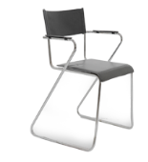 | 45
2104 | Folding Chair | 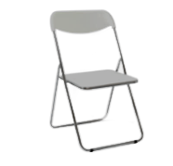 | 20
502 | 1-Tier Bistro Table (white) | 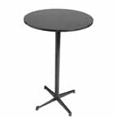 | 80
504 | Round Table (white) | 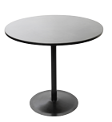 | 55
512 | Square Table (white) | 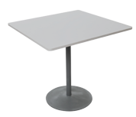 | 55
402 | Round Bar Stool | 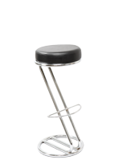 | 50
601 | Reception Desk  750mmH x 980mmW x 480mmD | 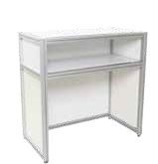 | 60
602 | Lockable Cabinet  750mmH x 980mmW x 480mmD | 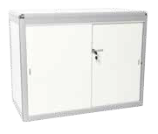 | 65
603 | Lockable Reception Cabinet  1000mmH x 500mmW x 1000mmD |  | 120
605/ 606/ 607 | Display Block  500mmH x 500mmW x 500mmD  750mmH x 500mmW x 500mmD  1000mmH x 500mmW x 500mmD |  | 60  90  120
709 | Metal Brochure Rack | 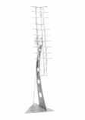 | 90
708 | Ziggy Brochure Rack |  | 110
604F/S | Wall Shelving – Slope/Flat  2000mmH x 1000mmW x300mmD |  | 40
707 | Wastepaper Basket  300mmH x 290mmW x 290mmD |  | 10
SUB-TOTAL
(*GST is not applicable for foreign-based exhibitors) 7% GST
TOTAL AMOUNT

Mode of Payment

For Singapore Exhibitors:
Cheque Payment should be made payable to Cityneon Events Pte Ltd

For Overseas Exhibitors:
By Telegraphic Transferring, our details are as follow:

CITIBANK, N.A.
8 Marina View,
#17-01 Asia Square Tower 1,
Singapore 018960
ACCOUNT NO.: 0-853373-117
ACCOUNT NAME: CITYNEON EVENTS PTE LTD
SWIFT CODE: CITISGSG
BANK CODE: 7214
BRANCH CODE: 001

Exhibiting Company ______________________________________ Booth No. ___________
Address _________________________________________________________________________
Contact Person ________________________________Designation ________________________
Tel __________________________ Fax __________________________
Email_______________________________________________________________________________

Important Notes:
- Orders are valid only when accompanied by full remittance. Payment could be made by Singapore local cheque, bank draft, telegraphic transfer or credit card.
- Amount paid are non-refundable should the event be cancelled or withdrawn.
- All bank charges (including beneficiary) must be borne by exhibitor.
- On-site orders may not be provided and, if available, will be subject to a 50% surcharge. Priority will be given to advance orders.
- All items are on rental basis for the period of the exhibition only.

- Price quoted DOES NOT include the power sockets or software for the equipment. Please order the power points for the equipment by submitting Electrical Services Form.
Form T5: Audio Visual Equipment
Please email this form to:-
Cityneon Events Pte Ltd
Cityneon Building, 25 Tai Seng Avenue #06-01, Singapore 534104
Attn: Ms Jade Yang
Email: runqiu.yang@cityneongroup.com
Tel: +65 6571 6271

FORM T5 - Optional
For Exhibitors
Form Due: 28 June 2019
- Orders will only be processed upon receipt of full payment.
- Late surcharge of 30% will be imposed on additional orders made after 28th June 2019 and a 50% late surcharge for any orders made on-site.
- Cancellation clause: Full cost shall apply for any cancellation received after 12th July 2019.
Description of service / items | Unit Cost SGD | Quantity | Total SGD
A) SLIM-LINE PLASMA VIDEO WALL – Per panel size: 686mm X 1215mm
2 x 2 | $6,000.00
3 x 3 | $10,000.00
B) LED Wall (min. 3x3) – Per panel size : 768mm X 960mm / size: 960mm X 960mm
6mm per panels (indoor) | $750.00
C) LED TV & Touch Screens
32” LED TV c/w USB input | $400.00
32” TouchScreen c/w Laptop | $1,500.00
42” LED TV c/w USB input | $600.00
42” TouchScreen c/w Laptop | $1, 900.00
50”LED TV c/w USB input | $800.00
50”4K LED TV c/w USB input (UHD) | $1200.00
55” LED TV c/w USB input | $1,000.00
60” LED TV c/w USB input | $1,200.00
60” 4K LED TV c/w USB input (UHD) | $1,400.00
- TV Accessories
HDMI Cable | $80.00
VGA Cable | $80.00
Plasma Floor Stand | $150.00
E) PROJECTORS
LCD Projector (4000 Lumen) | $880.00
LCD Projector (6000 Lumen) | $1,850.00
LCD Projector (13000 Lumen) | $3,200.00
E) PROJECTORS SCREENS
Kramer Switcher (VP-724) | $375.00
6 ft X 6 ft Tripod Screen | $180.00
6 ft X 8 ft Fast-fold Screen | $270.00
7.5 ft X 10 ft Fast-fold Screen | $500.00
8 ft X 8 ft Tripod Screen | $300.00
9 ft X 12 ft Fast-fold Screen | $600.00
10.5 ft X 14 ft Fast-fold Screen | $700.00
15 ft X 20 ft Fast-fold Screen | $1, 600.00
F) LAPTOP & Desktop
Laptop I7 | $530.00
Ipad/Tablet | $600.00
F) Sound System
PA system including 16-Channels built-in effect Mixer, Dual CD Mixer , Power Amplifier, 1 pair of EVZX5 Speaker/Stand & 2 x SLX Wireless Microphone | $2, 000.00
1 Pair of Speakers | $300.00
Microphone (Wireless Hand-held) | $120.00
Microphone (Lapel) | $120.00
Gooseneck (Rost) | $75.00
1 Pair of Mounting Speakers | $450.00
Conference Microphone | $120.00
Power Unit | $375.00
Promic (1 x Handheld, 1 x Headset, CD Player) | $300.00
DJ (per Day) | $600
G) Lighting
Moving Light with controller programmer | S$1, 200.00
Light Board | $600.00
Programmer | $375.00
Parcan 330W | $105.00
Parcan 1000W | $180.00
Moving Heads | $600.00
LED Par | $300.00
LED Bar | $200.00
Source 4 | $180.00
Dimmer | $300.00
Follow Spot | $675.00
G) Accessories
Platform/Stage per square meter | $120.00
Truss per meter | $80.00
Technician Standby | $360.00
Total Cost without GST
Total cost inclusive of prevailing GST

Mode of Payment

For Singapore Exhibitors:
Cheque Payment should be made payable to Cityneon Events Pte Ltd

For Overseas Exhibitors:
By Telegraphic Transferring, our details are as follow:
*NOTE: Applicable to overseas companies, please add 40 SGD for bank charges.

CITIBANK, N.A.
8 Marina View,
#17-01 Asia Square Tower 1,
Singapore 018960

ACCOUNT NO.: 0-853373-117
ACCOUNT NAME: CITYNEON EVENTS PTE LTD
SWIFT CODE: CITISGSG
BANK CODE: 7214
BRANCH CODE: 001

Exhibiting Company _____________________________________ Booth No. ___________
Address_________________________________________________________________________
_________________________________________________________________________
Contact Person _______________________________Designation ________________________
Tel __________________________ Fax __________________________
Email __________________________________________________________________________

Important Notes:
- Orders are valid only when accompanied by full remittance. Payment could be made by Singapore local cheque, bank draft, telegraphic transfer or credit card.
- Amount paid are non-refundable should the event be cancelled or withdrawn.
- All bank charges (including beneficiary) must be borne by exhibitor.
- On-site orders may not be provided and, if available, will be subject to a 50% surcharge. Priority will be given to advance orders.
- All items are on rental basis for the period of the exhibition only.

Please note that if we do not receive this form by 5th July 2019, the Internet Access Point will not be provided.
Form T6: Internet Access Point
Please email this form to:-
SCCCI
Attn: Ms Tiffany Shia | Mr Chris Foo
Email: tiffany@sccci.org.sg | chris@sccci.org.sg
Tel: +65 6430 8312 | +65 6430 8371

FORM T6
For Exhibitors
Form Due: 5 July 2019
Company Name:
Booth Number:
Contact Person:
Contact Number:

Please assist to submit the following information below:-

I *want / *do not want to have the internet access point at my booth.
(*Please delete accordingly)

Please indicate an “X” on the diagram below for the preferred access point location.

Backwall

Sidewall / Open*
Sidewall / Open*

Open Front

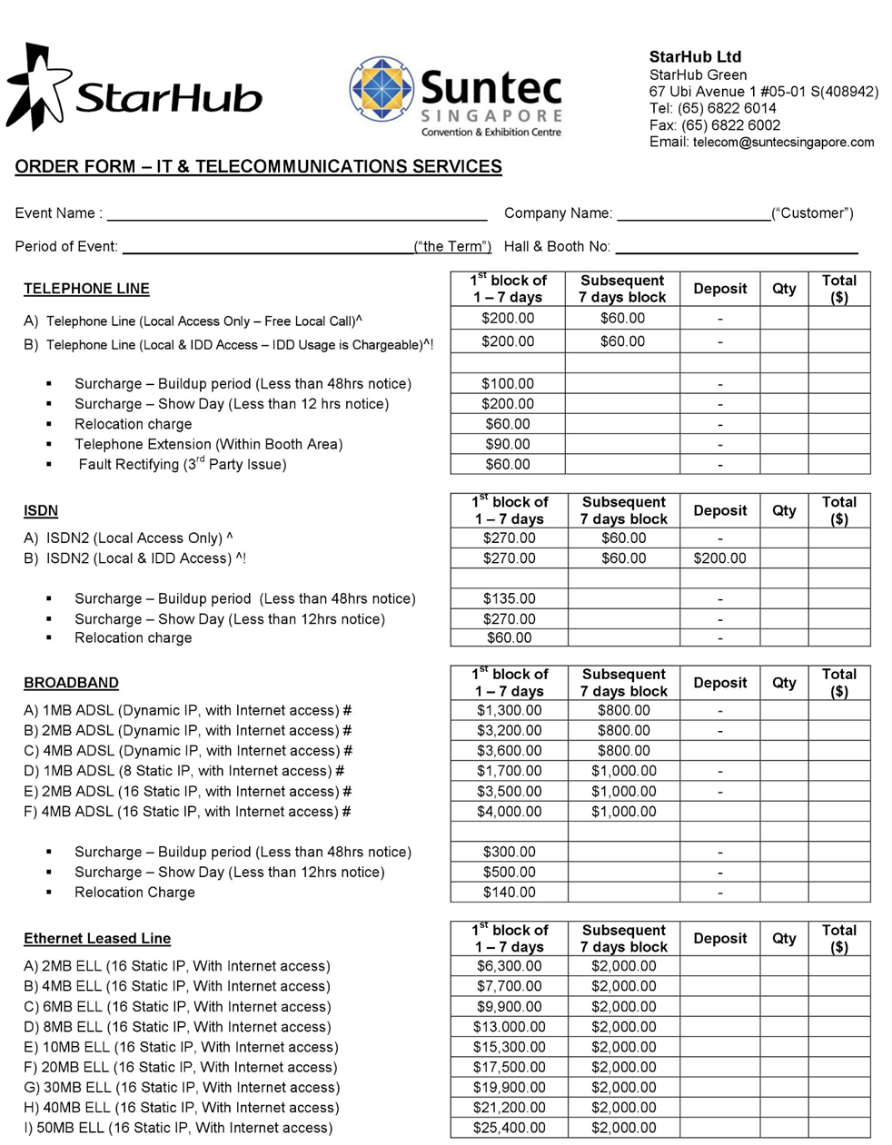
Form T7: Additional Internet Access Point
Please email this form to:-
SCCCI
Attn: Mr Chris Foo
Email: chris@sccci.org.sg
Tel: +65 6430 8371

FORM T7 - Optional
For Exhibitors
Form Due: 5 July 2019
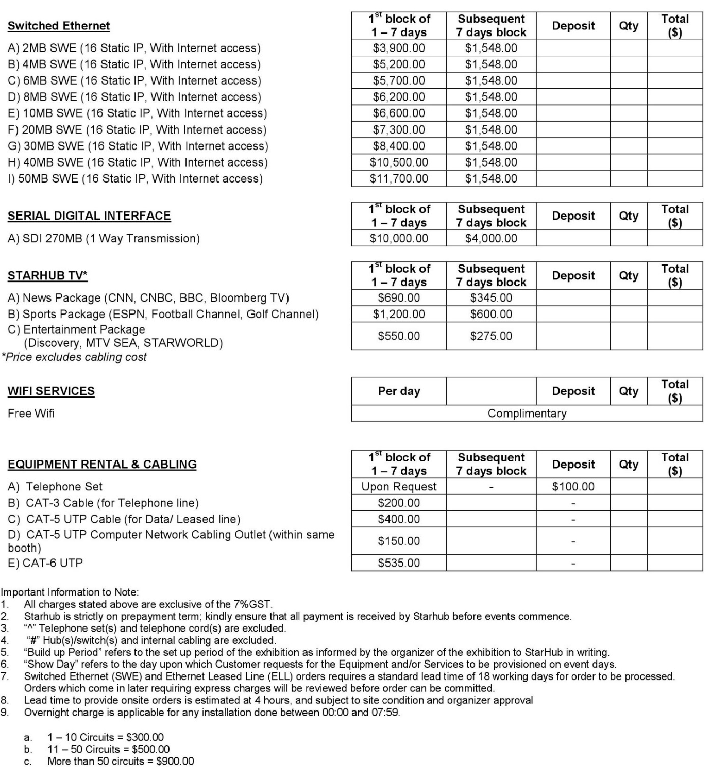

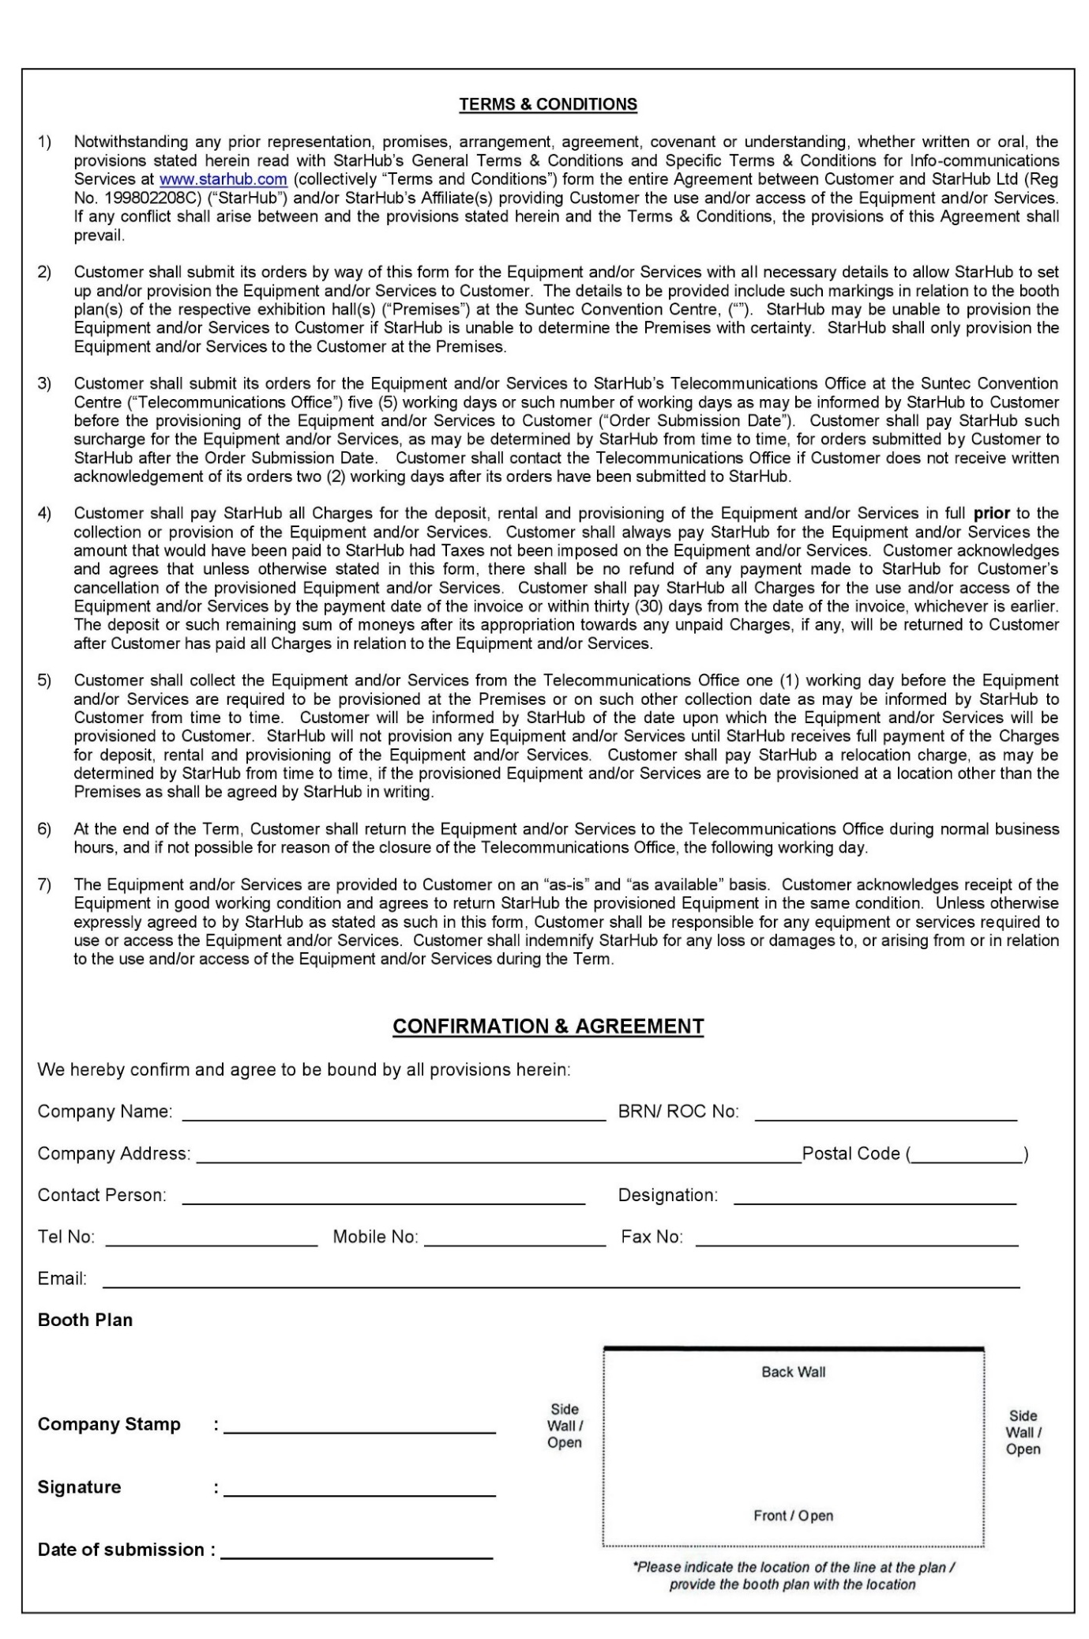
Please submit the list of names for the Complimentary Delegate Passes by completing the attached Excel Sheet with the Registration Template.
Form T8: Complimentary Delegate Passes
Please email this form to:-
SCCCI
Attn: Ms Tiffany Shia | Mr Chris Foo
Email: tiffany@sccci.org.sg | chris@sccci.org.sg
Tel: +65 6430 8312 | +65 6430 8371

FORM T8
For Exhibitors
Form Due: 19 July 2019

This is meant for Exhibitors to invite their Management Team, Business Partners, Clients and Associates to attend the SME ICC 2019 as a Delegate.

Upon submission of the list of names for the pass, participants will be receiving a Confirmation Email and the Conference Delegate Pass directly from SCCCI. There is no limit to the number of Complimentary Delegate Passes each Exhibitor is entitled to.

For Exhibitors manning the booths in the SME Expo, an Exhibitor Pass will be issued for identification purposes – these passes are generically marked “EXHIBITOR” and can be shared amongst colleagues manning the booths during the exhibition.

Early access to the Exhibition Hall before the event begins is strictly limited to those holding the “EXHIBITOR” passes – Conference Pass holders will be allowed in only during the official opening hours.
TIP: It is important to plan for adequate manpower stationed at the booth, especially on Day 1 of SME ICC in order to ensure maximum exposure and outreach.
Sample of Complimentary Delegate Pass and Exhibitor Pass

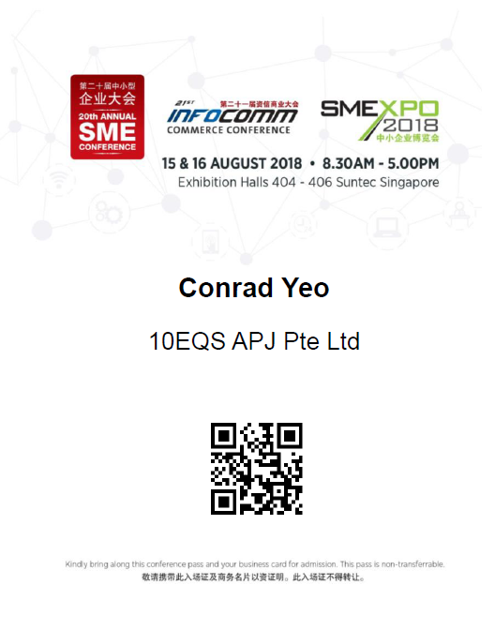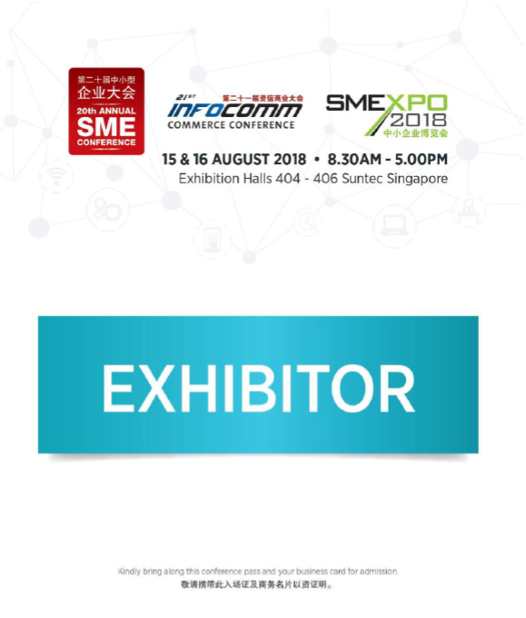
Sponsors and Exhibitors are entitled to ONE (1) Facebook Post on the official SME ICC Facebook Page. Submitted posts must be related to SME ICC and the Exhibiting Company – content of the posts can be directed at Sales Promotion, Raising Awareness for the Company etc and will be subjected to review by SCCCI.
Form T10: Facebook Post
Please email this form to:-
SCCCI
Attn: Ms Tiffany Shia | Mr Chris Foo
Email: tiffany@sccci.org.sg | chris@sccci.org.sg
Tel: +65 6430 8312 | +65 6430 8371

FORM T10 - Optional
For Exhibitors
Form Due: 1 August 2019
The post will be scheduled by SCCCI based on the current availability of slots on the SME ICC Facebook. Any posts received after the stipulated deadline will not be entertained.
Please submit the following content for the post:-
- Image (Dimensions: 1,200 pixels by 628 pixels)
- Content Write-Up (maximum 100 words)
- Link (either to Company Website or Facebook Page)
Sample of Facebook Post
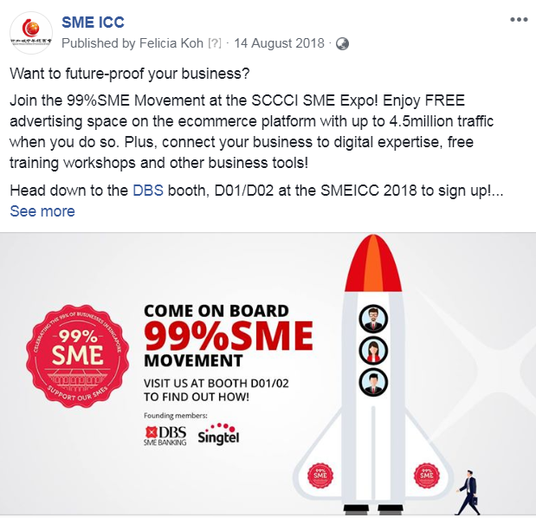
SAMPLE

